
Model comparison
report of TP 1
Parameter estimation

Wenxu zhao
Liwei XU
Wenqian YE
Yuteng WANG

Marc FISCHER
10.2020

- Model 1

Question 2:
Check and visualise the priors. Verify that their integrals are always equal to 1.

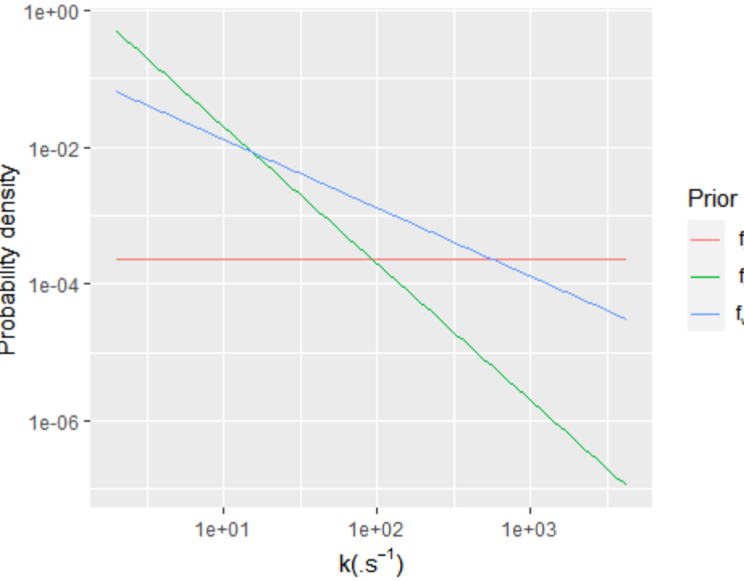
Figure 1 three priors

Question 3:
Plot the profile for k = 1.357e+03 /s and compare it with the measurements

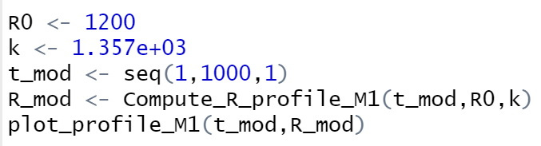

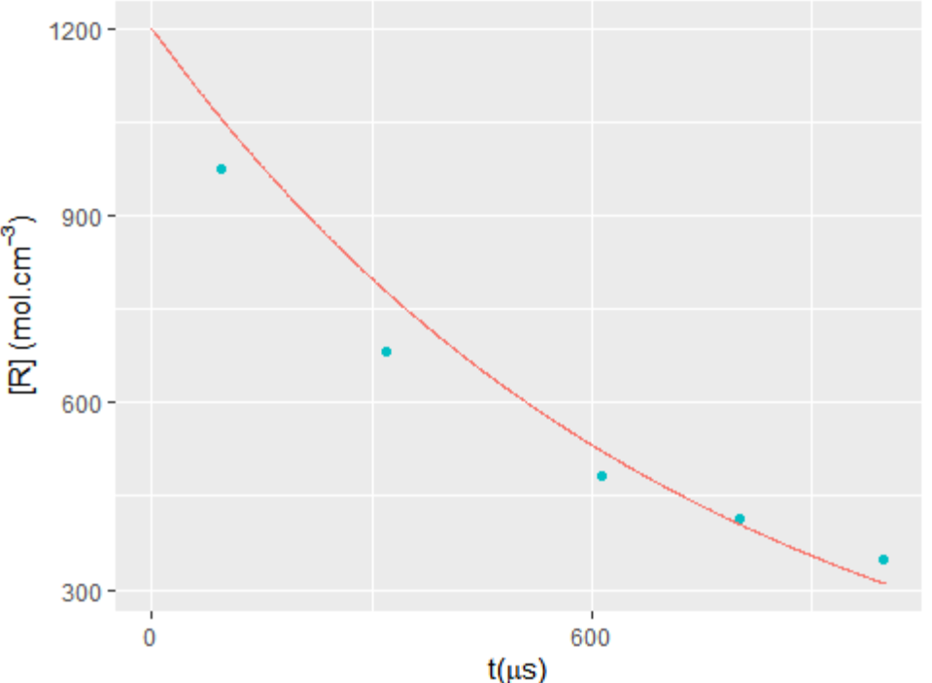
Figure 2 profile of the first model

Question 4:
1.Plot the likelihood and verify that the optimal point is approximately k = 1.357e+03 /s.
2.Focus on the region where the likelihood has the strongest values for producing the graph.
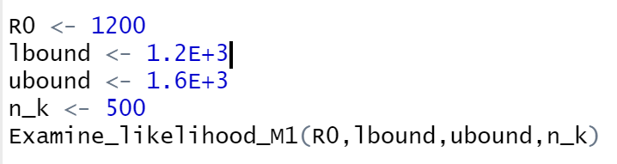
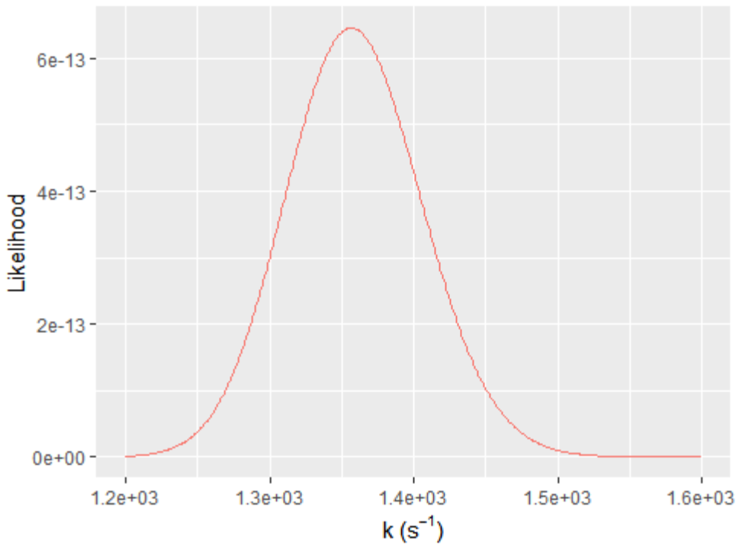
Figure 3 distribution of the likelihood

Question 5
1.Compute the posterior probability distributions corresponding to the three priors. Check that their integrals are equal to 1.
2.Represent them graphically. Choose an appropriate interval where the values of the likelihood (and therefore also of the posteriors) are the highest.
3.While representing the graphic, increase manually its width if the axis values aren’t readable

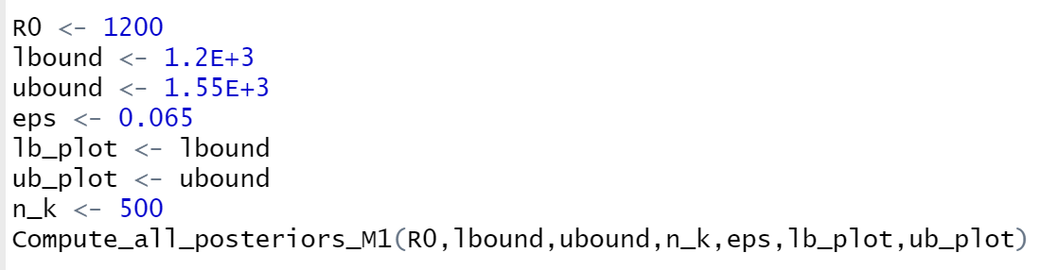
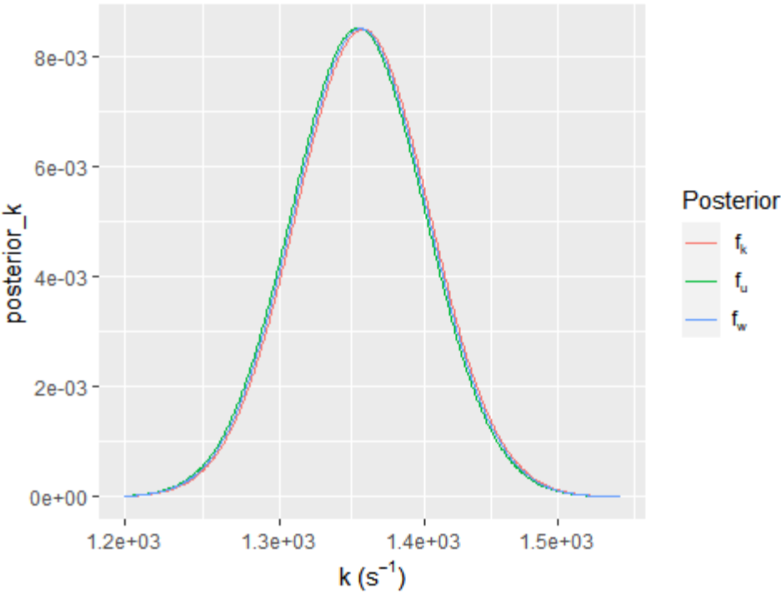
Figure 4 posteriors distribution
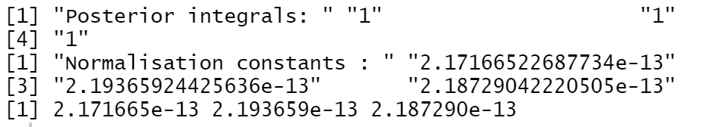

We can see plot of the posterior probability distributions corresponding to
the three priors, we notice that their integrals is equal to 1.

Question 6
For each of the three priors, compute the prior probability that k belongs to the interval [1000;1500].
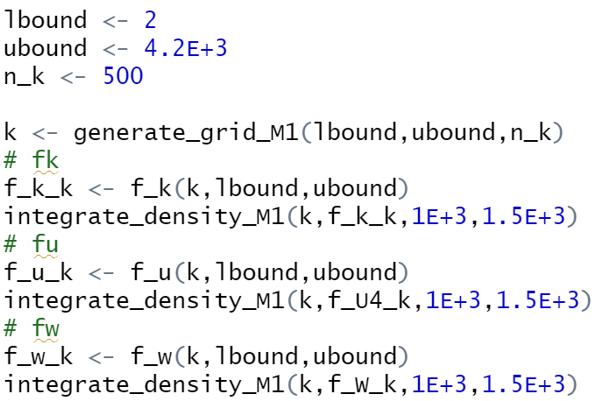
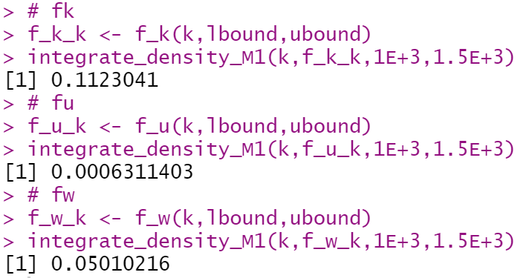
Figure 5 there prior probability

No,three priors are not relatively good agreement with one another

Question 7
Compute now the three corresponding posterior probabilities p (k1∈[ 1000 ;1500]|experiment)
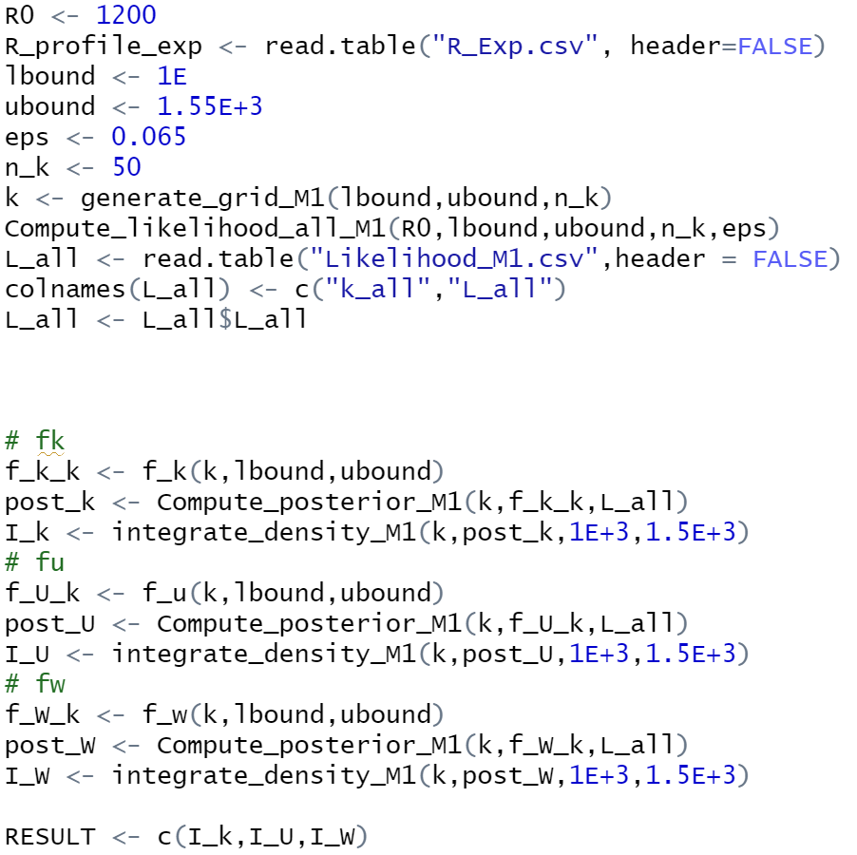
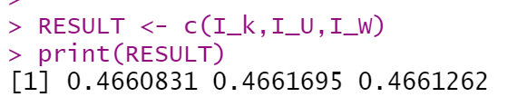
Figure 6 three posterior probabilities

In this case,we can get the same three posterior probabilities,so the prior have small effect on the posterior probability distribution

Question 8
Compute now the three posterior probability distributions for k1∈[ 2;4.26E+3] s−1 and ϵ=30%
Plot the three posteriors for ϵ=6.5 % and the three posteriors for ϵ=30% beside one another
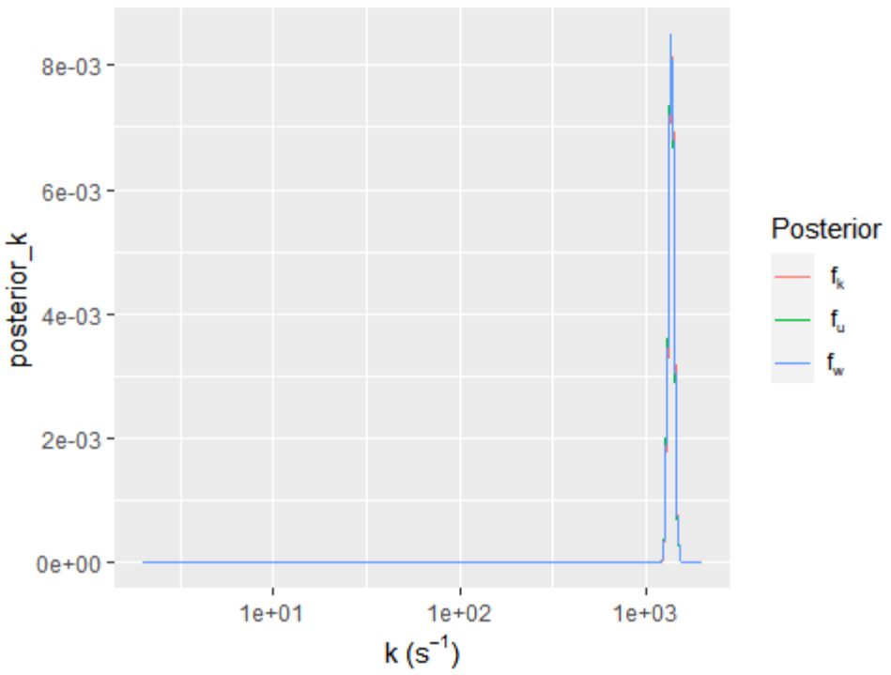
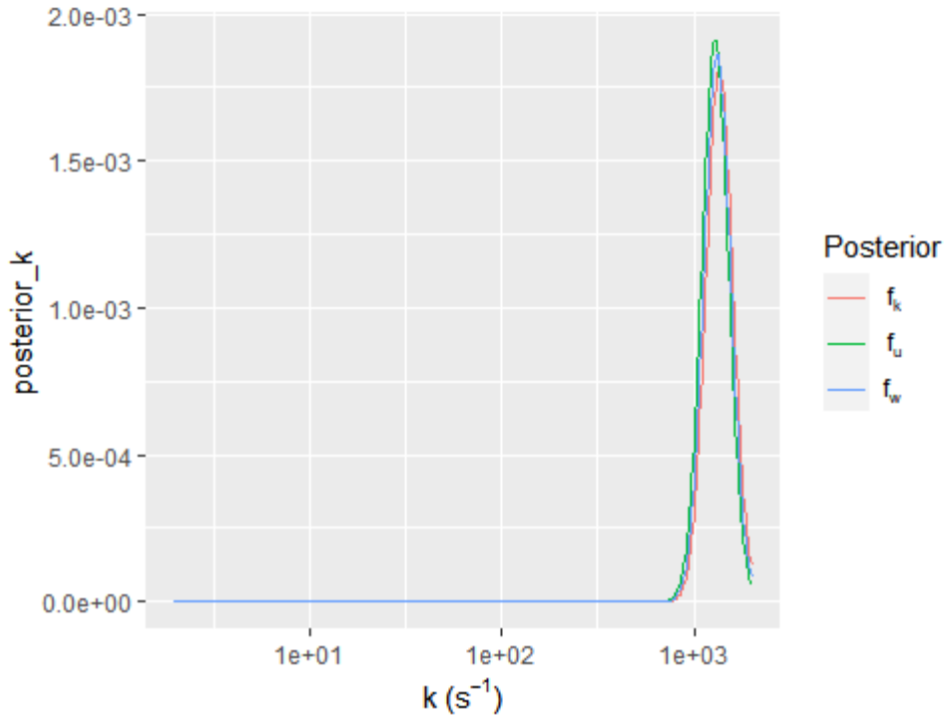

Question 9
Calculate now the three posterior probabilities p (k1∈[ 1000 ;1500]|experiment)for ϵ=30%. Compare them with those for ϵ=6.5 %

For epsilon 0.065
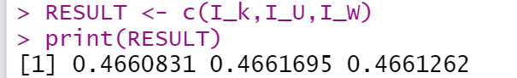
For epsilon 0.3
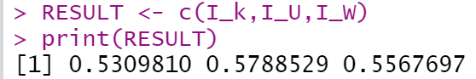
Likelihood epsilon 0.065
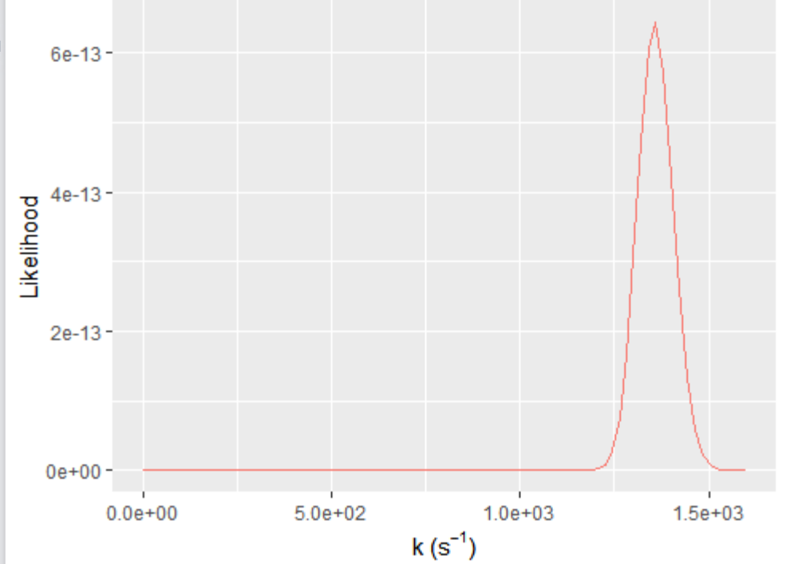
Likelihood epsilon 0.3
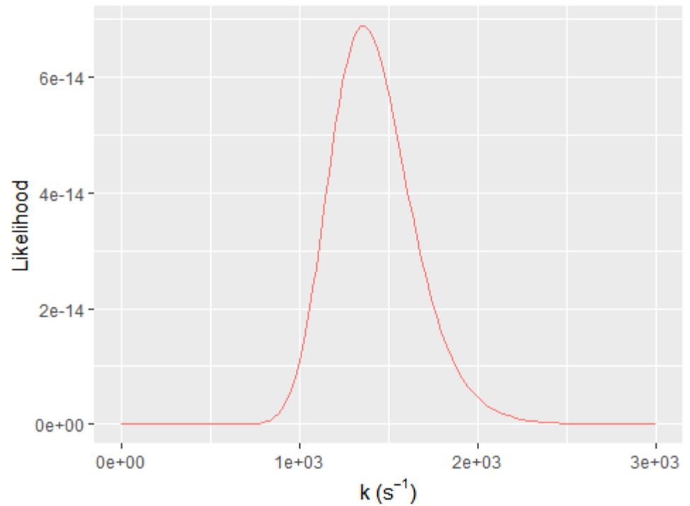
maximum likelihood for esp= 0.065 is bigger than the esp = 0.3
- Model 2

Question 2
Compute and plot the three priors
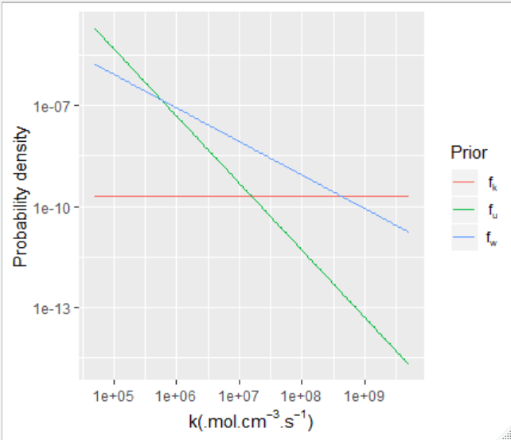

Question 3
Compute the likelihood.
Plot it in an appropriate, narrower interval
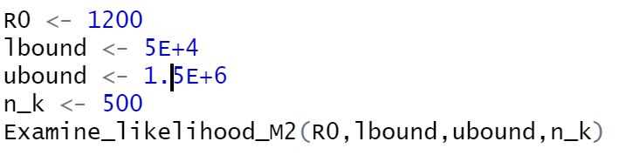
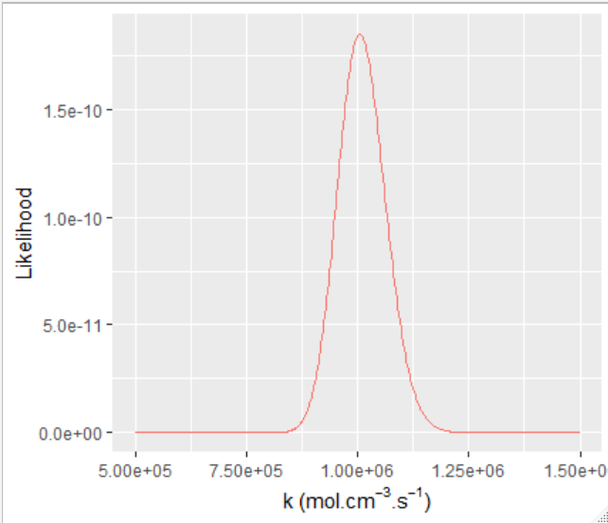
choose to narrow the interval : [5 E+05; 1.5E+06]
Question 4
Plot the optimal profile for M2.
Compare it to the optimal profile for M1

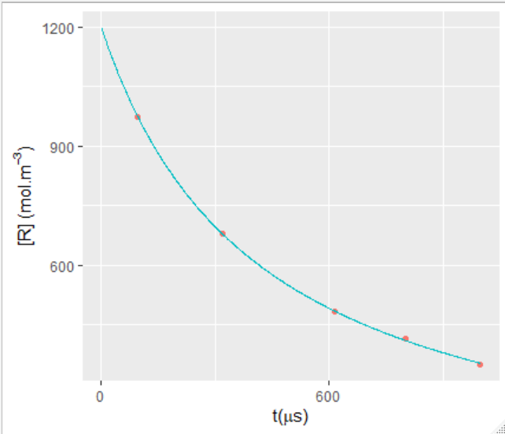

Question 5
Compute the three posterior probability distributions
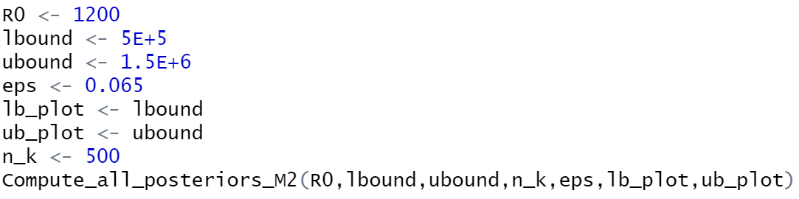
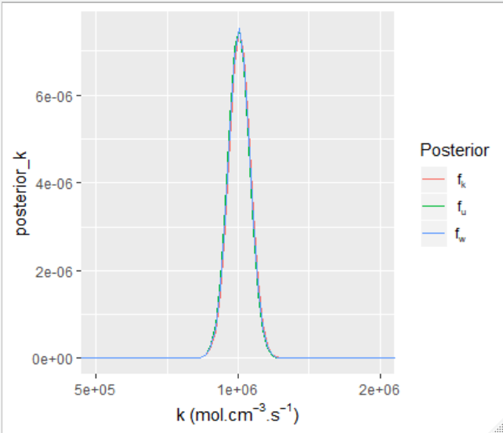
3 values of the returned vector of posterior integrals are equals to 1

